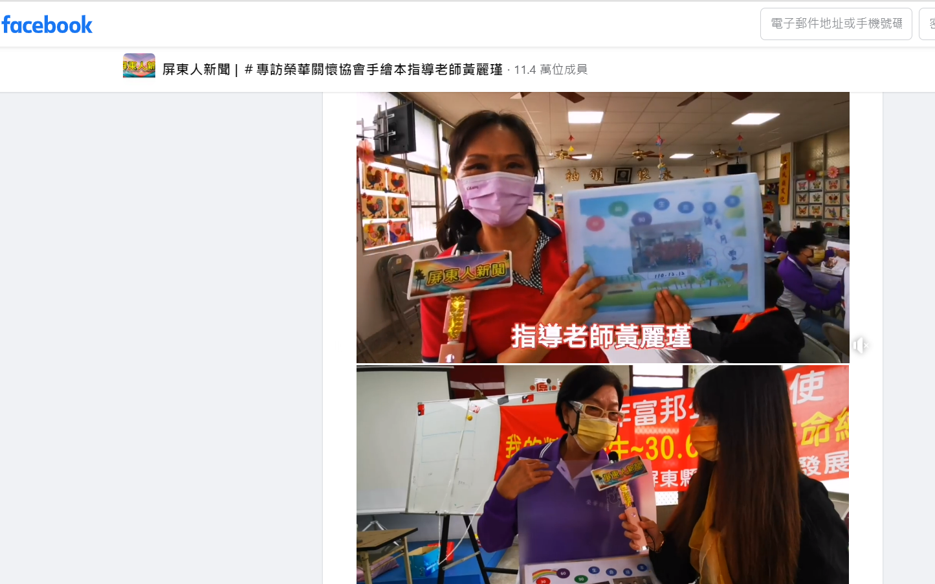
連結網址:https://www.facebook.com/groups/1524648621188142/permalink/3080244372295218/

