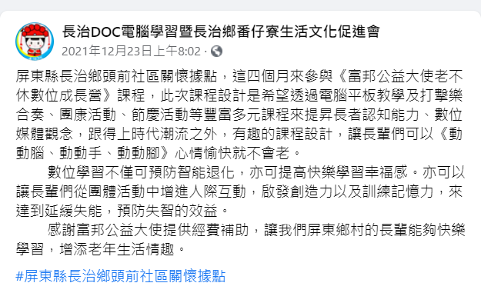
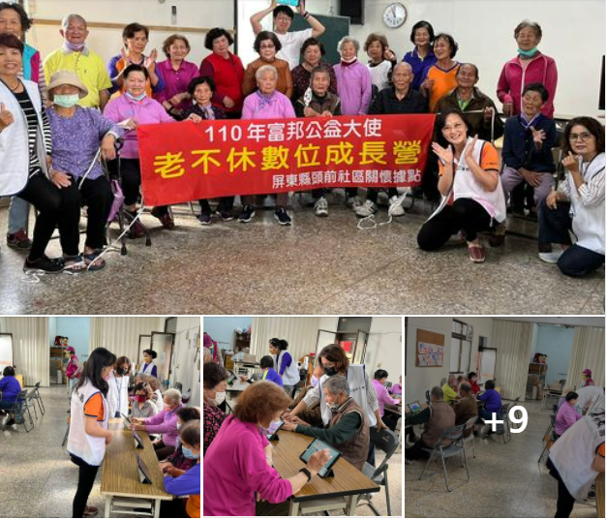
https://www.facebook.com/changzhidoc/photos/pcb.1372073866580507/1372073473247213/

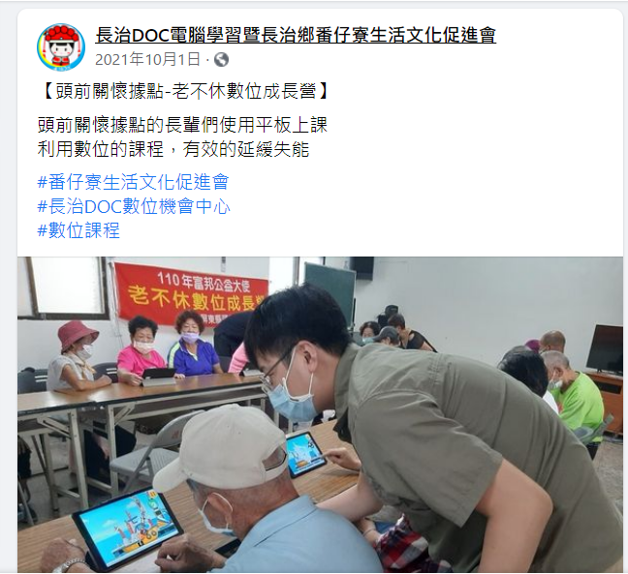

https://www.facebook.com/changzhidoc/photos/pcb.1316744102113484/1316742865446941/

