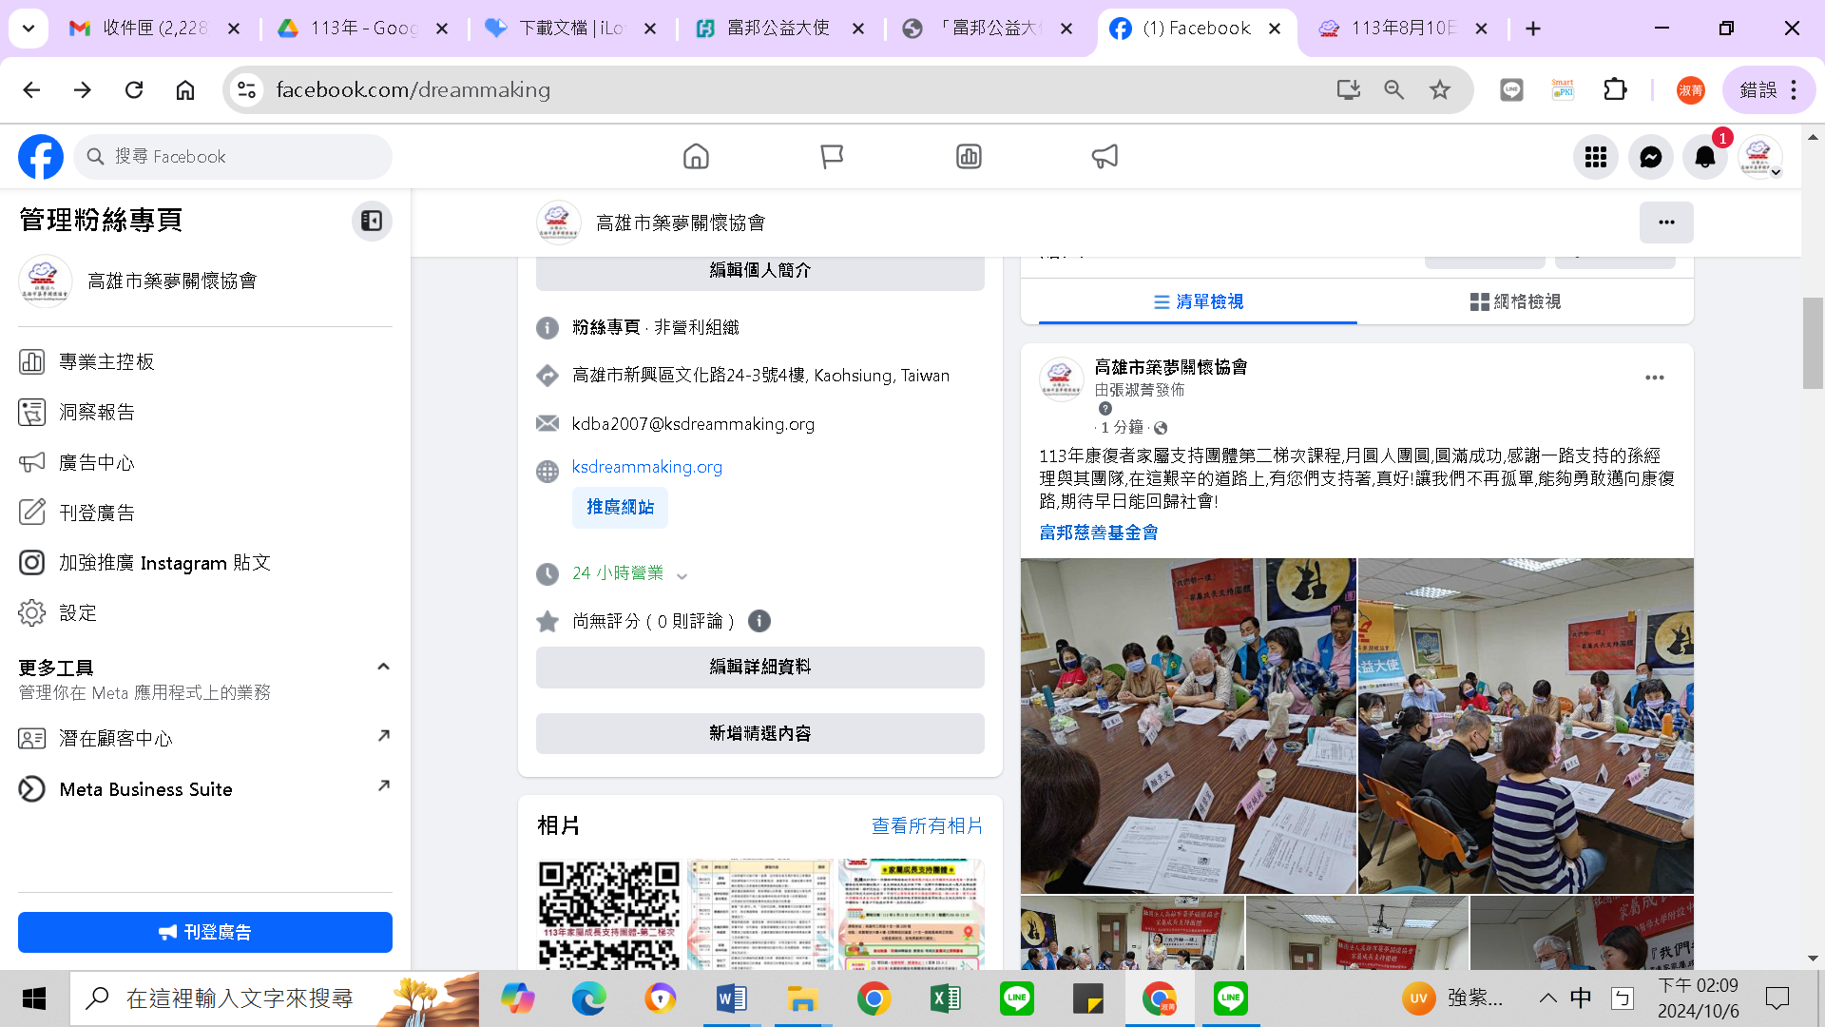

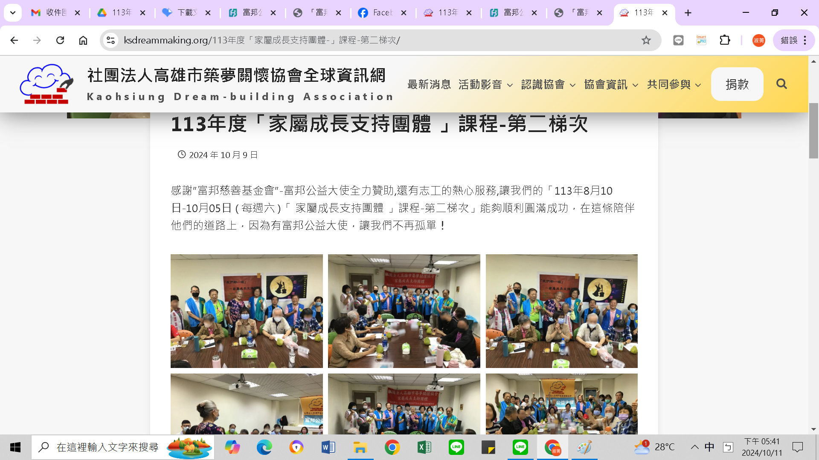

https://www.ksdreammaking.org/113%e5%b9%b4%e5%ba%a6%e3%80%8c%e5%ae%b6%e5%b1%ac%e6%88%90%e9%95%b7%e6%94%af%e6%8c%81%e5%9c%98%e9%ab%94-%e3%80%8d%e8%aa%b2%e7%a8%8b-%e7%ac%ac%e4%ba%8c%e6%a2%af%e6%ac%a1/