活動媒體露出
https://www.youtube.com/watch?v=-oVfPrFkeBM&feature=youtu.be
接受竹科之音 任樂倫小姐的採訪

中興巴士員工體驗
https://www.facebook.com/CSbus/posts/1203770993142479

媒體報導
蘋果日報 人物微視蘋 專訪
https://tw.appledaily.com/new/realtime/20190916/1616106/
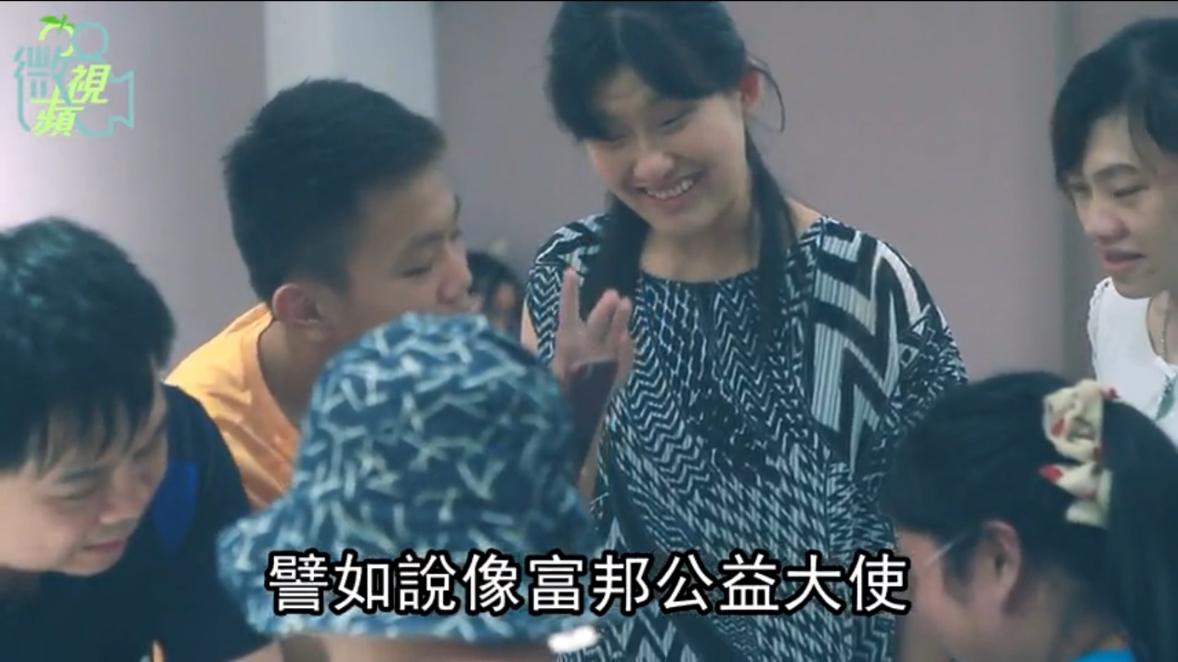

活動文宣宣傳
https://www.facebook.com/blindlove.tpcnice/posts/2350689461917170
https://www.facebook.com/events/683328568758122/

